Routing
riproduce la traccia giusta dal player matlab e nel frattempo muta il canale giusto di reaper tutto a seconda dello stato corrente dell’applicazione. Attualmente non c’è mai ogni volta che si incrementa il counter nessuna (stessa) traccia su tutti i canali del mio reaper, per velocizzare il debugging non ho completato il routing, ma mi serve solo per capire in queste prove se sta suonando lo speaker (canale) corretto e quindi la funzione di muting con i comandi osc funziona sempre bene.
dato che tutti i canali di reaper nella sala di sotto saranno in ascolto su “AES(1)” sulla quale è attivato il loopback sul software di gestione della scheda audio, ci è sufficiente lunedì mattina per generalizzare il tutto di far scrivere al player di matlab la traccia giusta (a seconda dello stato del test) anziché sull’output corrispondente alle casse del mio pc, sull’ingresso “AN1/2” di cui a sua volta solo il sx va su “AES_L” che è il corrispondente sull’interfaccia scheda audio di AES(1) e il tutto funziona?
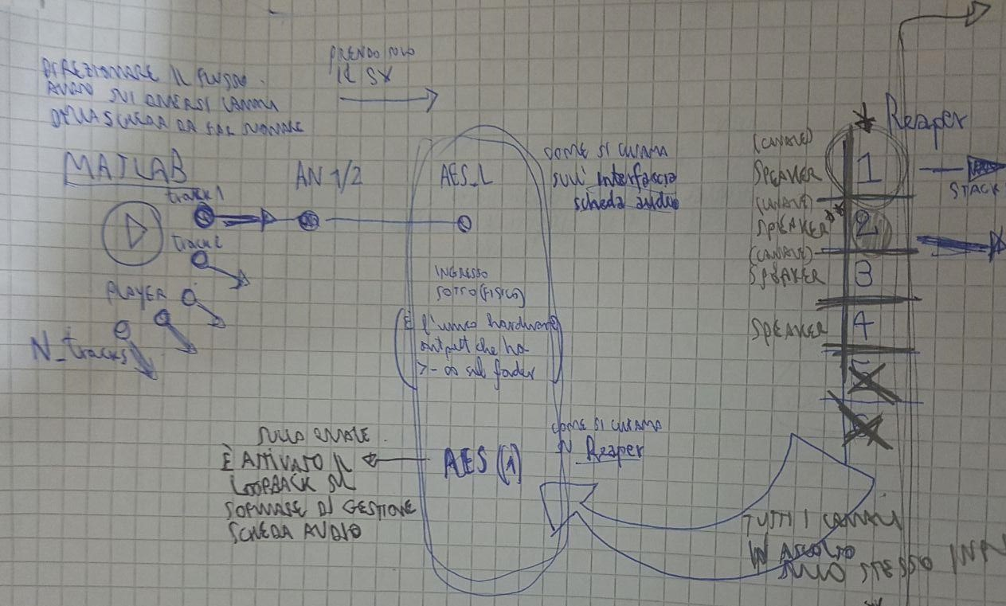
E’ necessario cioè fare soltanto una cosa del genere:
https://it.mathworks.com/help/audio/ref/audiodevicewriter-system-object.html ?
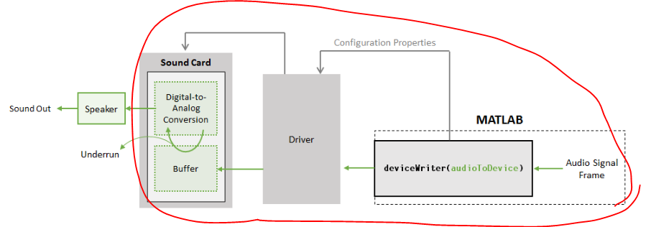
Devo perciò implementare un flag in tal caso che se premo “NEXT” stoppo la traccia che stava suonando per valutare quell’attributo corrente e “riaccendo” quella giusta successiva (mandandola ancora a scrivere su tutti i canali dove c’è il loop) soltanto quando premo PLAY nella schermata successiva?
MECCANISMO SU QUALE CANALE SCRIVERE

This tutorial describes how MATLAB® software implements real-time stream processing:
[https://it.mathworks.com/help/audio/gs/audio-io-buffering-latency-and-throughput.html]
https://it.mathworks.com/help/audio/ref/audiodevicewriter-system-object.html
https://it.mathworks.com/help/dsp/ref/audiodevicewriter.getaudiodevices.html#d117e210546
https://it.mathworks.com/help/audio/ref/asiosettings.html

Sampling del latinsquare (OK)
• Mentre invece per quanto riguarda il discorso del sampling verticale come si modifica a partire dal balanced latin square
VERSIONE 2
111 116 125 134 213 223 232 311 316 325
VERSIONE 3 (tre soggetti iniziano dallo speaker 1, quattro dallo speaker 2 e tre dallo speaker 3)
111 112 113 213 221 222 223 311 312 313
Così va bene se faccio il debugging con questi tentativi?

Loudness equalization
[zach2019] The loudness of the presented stimuli may have a major influence on the results of a listening test. For product sounds it is often the most important variable and for reproduced sound it also has a major influence at least for three reasons:
• The frequency-dependent loudness characteristics of the ear will change the perceived timbre of the stimuli at different levels (see also Figure 3.1);
• Distortion components at higher frequencies may be masked by low frequency components, and the masking depends on the level;
• The physical properties of systems under test, e.g. distortion, bandwidth, equalisation, etc., may change with the level.
If the systems under test are meant for sound reproduction, e.g. loudspeakers and headphones, it is important that the systems under test are aligned to the same level. It is a common experience that if two loudspeakers with relatively similar characteristics are included in a test, the loudest playing loudspeaker will be preferred. In such cases loudness alignment should be carefully considered.
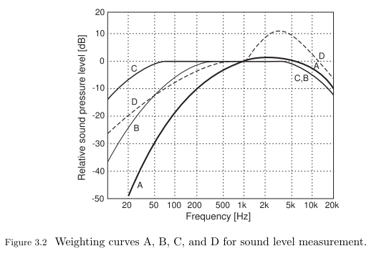
As the SPL in decibels is defined equal for all frequencies in Equation ($SPL=20\log_{10}\left(\frac{p}{p_{0}}\right)$) it does not account for such complex frequency and level dependencies (pagina 27, curve di fletcher and munson)
To obtain simple, yet superior, measure of the perceived loudness of a sound, the concept sound level is defined, a.k.a., frequency-weighted sound pressure level. It is a measure with a frequency-dependent weighting which roughly approximates the frequency-sensitivity of hearing shown in Figure 3.1. Four different weighting curves have been defined: A, B, C, and D curves, as shown in Figure 3.2 (IEC 61672-1, 2013). The A-weighted sound level is often used in noise measurements to characterise the perceived loudness, and also the risk of hearing loss. It slightly emphasises the levels at mid frequencies and attenuates them at low and high frequencies. It is easy to see that A-weighting is just a very rough estimate, which can be seen when the weighting curve is compared with the inverted equal-loudness curves. Technical simplicity and extensive use in practice are its advantages. The other curves (B and C) are meant to be used with mid-range and high SPLs, respectively, and the D curve was originally developed for noise at air fields. However, they are used rarely. The unit of all sound levels is decibel [dB], and it is common to show the weighting curve also, for example dB(A) for the A-weighted curve at a level of ∼40 Ph

A number of instrumental level and loudness alignment methods exists some are based on RMS measurements of test signals, e.g. pink noise, with different frequency and time weighting functions (see
• Figure 3.2 and IEC 61672-1 (2013);
• EBU R128 (2014);
[itu2015]
• ITU-R Rec. BS.1770-4 (2015))* $→$ REAPER (SWS)
The algorithm consists of four stages
- “K” frequency weighting; mean square calculation for each channel;
- channel-weighted summation (surround channels have larger weights, and the LFE channel is excluded);
- gating of 400 ms blocks (overlapping by 75%), where two thresholds are used:
– the first at −70 LKFS;
– the second at −10 dB relative to the level measured after application of the first threshold.
and others based on psycho-acoustic loudness metrics
• (ISO 532-1, 2017);
• (ISO 532-2, 2017).
Whilst, loudness alignment is often advised when comparison the systems under test, it may not always be justified. For example, it may be of interest to evaluate the loudness and sensitivity of a hearing aid for a given input signal as part of an overall evaluation of the devices performance. Furthermore, due to the frequency-, level- and temporal-dependent nature of loudness, at times it can become complex to perform loudness normalisation between systems with very different characteristics (e.g. width, equalisation and distortion). A pragmatic and effortless way to start, is to adjust the systems to the same A-weighted sound pressure level in the listening position with a pink noise signal and progress from there.

PREMESSA: https://www.learndigitalaudio.com/normalize-audio
SOLUZIONE
Se lo faccio in una DAW plugin gratuito di default per fare il metering tra loudness, modello che è un po' piu ragionevole Bob Katz (modello con loudeess) K-14 metering system
K-system metering it's a way of metering pioneered by Bob Katz, mastering engineer and grammy award winner. With the K-System, maximizing peak levels is no longer the goal; instead, your focus shifts to loudness metering and dynamic range.
The K-System has three scales: K-12, K-14 and K-20. You choose which scale to use based on genre and delivery format. K-12 is for broadcast and radio. K-14 is for mainstream pop, rock and country. K-20 is for film, classical and high-fidelity recordings. From K-12 to K-20, the scales provide an increasing amount of dynamic range.
http://www.aes.org/technical/documentDownloads.cfm?docID=65
(https://forum.cockos.com/showthread.php?t=120725)
if you are not yet mixing -20dbFS at 83db SPL you must watch this:
Bob Katz - music mastering and loudness Part 1
https://www.youtube.com/watch?v=8EgamkLkXW8
In part 2... he explains why we must abandon peak metering
Bob Katz - music mastering and loudness Part 2
https://www.youtube.com/watch?v=97bJ5J_mY14
http://www.stepa-sound.ch/files/downloads/audio/BobKatz.pdf
$→$ REAPER
https://forum.cockos.com/showthread.php?t=134561 (bob katz metering inside reaper)
What does "Display Offset" mean? It sets the RMS meter scale offset for 0 from "true" 0dB. 14dB would be like Bob Katz's K-14, with K-12 and K-20 available too.
Example:
Set the master set to RMS only, and use an offset of +13dB (or maybe it's the display gain). I do this so when the master is around 0 it means my mix is around -13db RMS which the level I'm aiming for (loud enough, but still headroom).
https://www.youtube.com/watch?v=wxb7jqxedUU
http://www.sws-extension.org/
C:\Program Files\REAPER (x64)
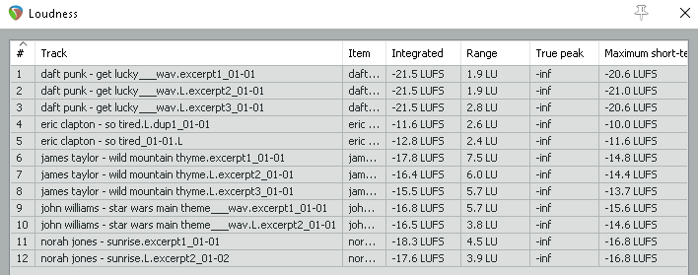
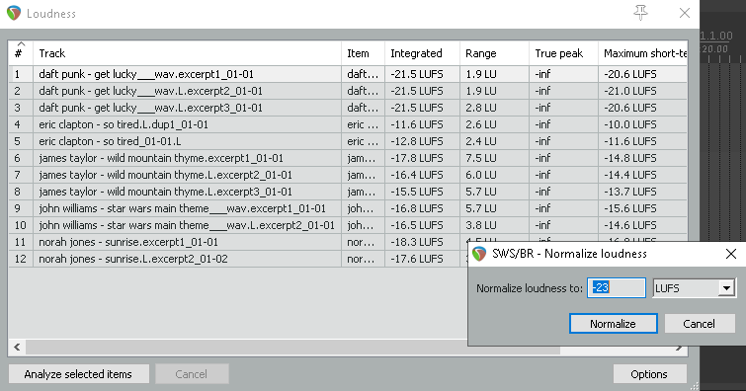
NORMALIZE TO THE QUITEST AND THEN BOUNCE TRACKS FROM REAPER!!!
https://forum.cockos.com/showthread.php?t=176882
TO CLARIFY (https://en.wikipedia.org/wiki/LKFS)
Loudness, K-weighted, relative to full scale (LKFS) is a loudness standard designed to enable normalization of audio levels for delivery of broadcast TV and other video.^{[1]}
*ITU BS.1770 standard[edit] LKFS is standardized in ITU-R BS.1770.^{[2]} In March 2011, the ITU introduced a loudness gate in the second revision of the recommendation, ITU-R BS.1770-2.^{[3]} In August 2012, the ITU released the third revision of this recommendation ITU-R BS.1770-3.^{[4]} In October 2015, the ITU released the fourth revision of this recommendation ITU-R BS.1770-4.^{[5]}
EBU R128 standard[edit] Loudness units relative to full scale (LUFS) is a synonym for LKFS that was introduced in EBU R128.^{[6]}
The EBU has suggested that the ITU should change the unit to LUFS, as LKFS does not comply with scientific naming conventions and is not in line with the standard set out in ISO 80000-8. Furthermore, they suggest the symbol for loudness level, k-weighted should be L_{k}, which would make L_{k} and LUFS equivalent when LUFS indicates the value of L_{k} with reference to digital full scale.^{[7]}
LKFS and LUFS are identical in that they are both measured in absolute scale and both equal to one decibel (dB).^{[8]}
Loudness units (LU) is an additional unit used in EBU R128. It describes L_{k} without direct absolute reference and therefore describes loudness level differences
|
|
|
BE CAREFUL! REMEMBER!
https://www.pro-tools-expert.com/logic-pro-expert/logic-pro-blog/2017/06/14/loudness-normalization-part-2-the-standards
Please note that there is some inconsistency with the labeling. The European standard uses the unit “LUFS”, but ITU and the US uses the unit “LKFS” (Loudness, K-Weighted, referenced to digital Full Scale). Both units are the same. The letter K is just an unfortunate choice, originally established by the ITU. It has nothing to do with the “K-System” proposed by Bob Katz, instead, it is referring to the so-called “K-Weighing Filter” that the Loudness Meter uses to measure Perceived Loudness.
|
|
|
[society2017]
$$\boxed{\begin{aligned}All tracks were level-{aligned}^{*} to avoid any level-dependent effect on the sound perception and had an \\ average duration of 25 seconds (minimum 19s, maximum 34s)\end{aligned}}$$* The track levels were decreased to match the perceived loudness of the quietest track in order to avoid introducing additional noise to the original recordings.

CON ITU BS 1770-4

64-bit VST2 plugin
C:\Program Files\Steinberg\Vstplugins
64-bit VST3 plugin
C:\Program Files\Common Files\VST3
AAX plugin
C:\Program Files\Common Files\Avid\Audio\Plug-Ins
Application folder
C:\Program Files\Youlean\Youlean Loudness Meter 2
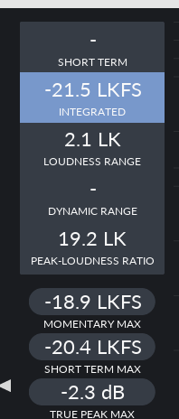 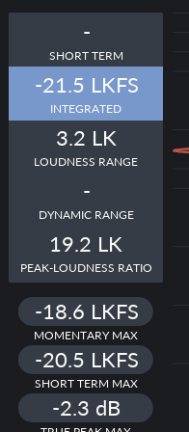 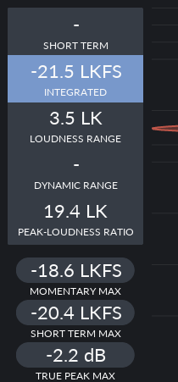
(GET LUCKY excerpt1, excerpt 2, excerpt 3 mono)
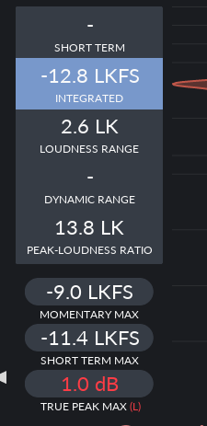 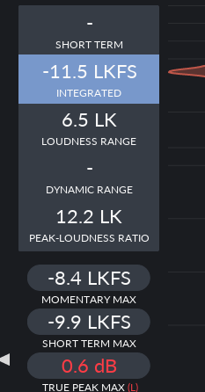
(SO TIRED, excerpt 1, excerpt 2)
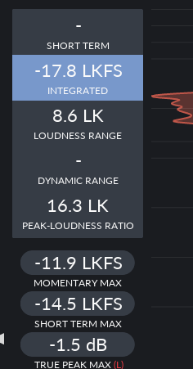 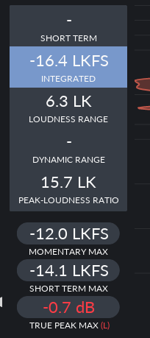 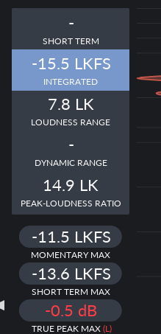
(WILD MOUNTAIN THYME excerpt1, excerpt 2, excerpt 3 mono)
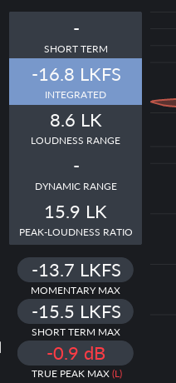 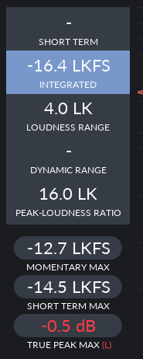
(STAR WARS excerpt 1, excerpt 2 mono)
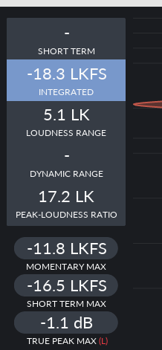 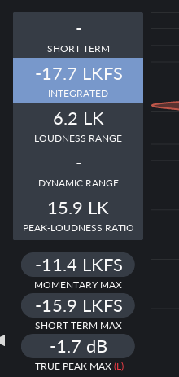
(SUNRISE excerpt 1, excerpt 2 mono)

